HOW CREATE A GITHUB ACCOUNT

1. **OPEN MICROSOFT EDGE AND SERACH GITHUB.COM**
2. 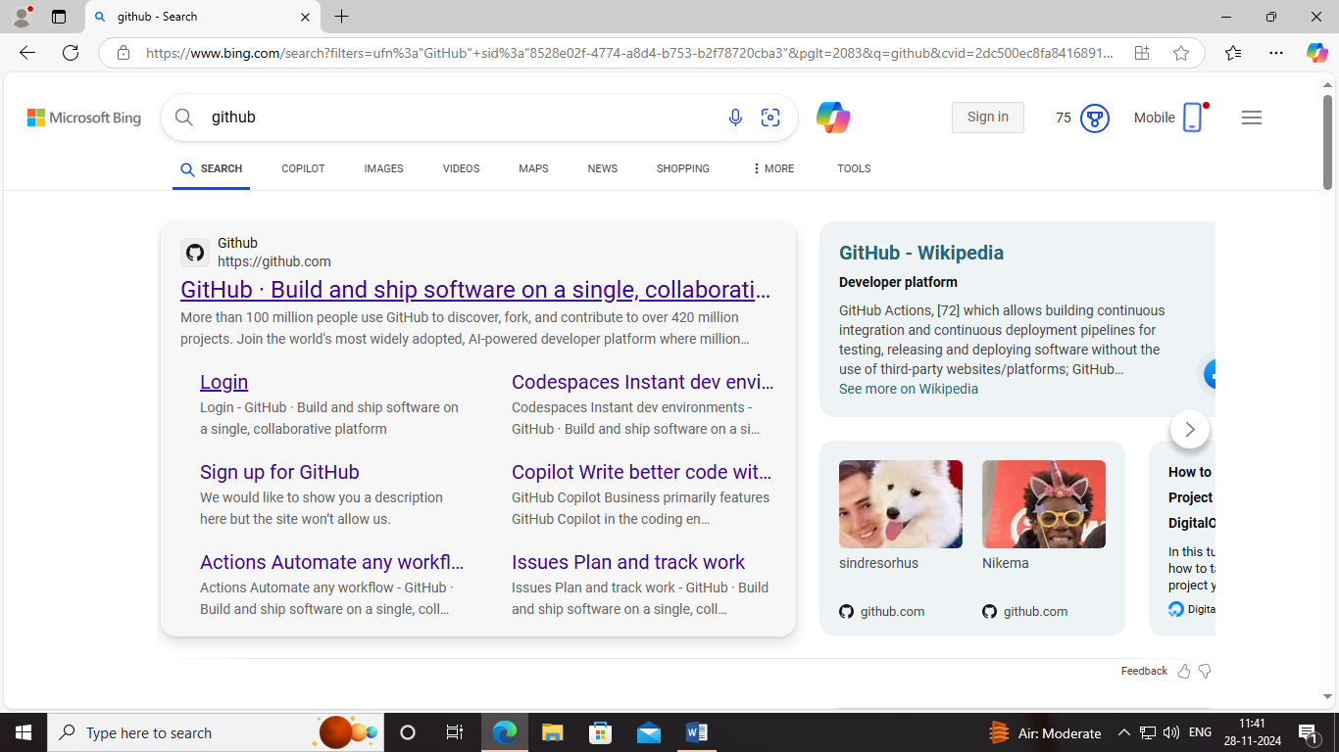
3. CLICK ON THAT LINK
4. SIGN IN WITH YOUR G-MAIL
5. 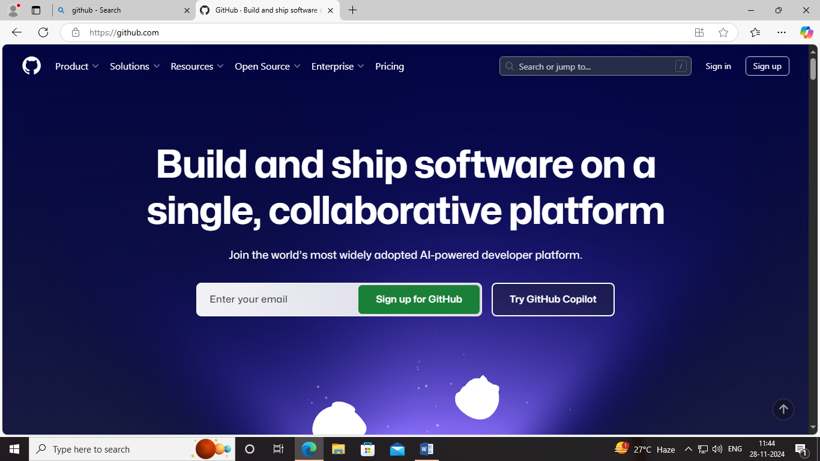
6. ENTER YOUR G-MAIL AND CLICK THE SIGN UP FOR GITHUB
7. 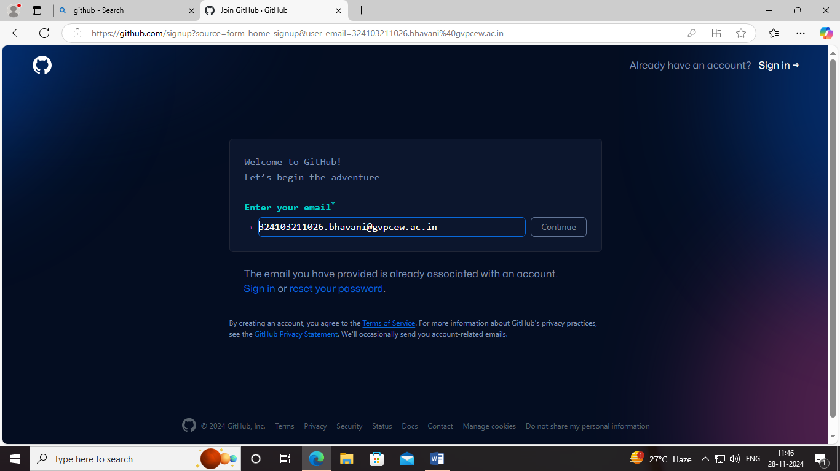
8. CREATE A PASSWORD
9. CREATE A USERNAME FOR GITHUB ACCOUNT
10. VERIFY YOUR ACCOUNT
11. G-MAIL GET A CODE ENTER THAT CODE
12. GITHUB ACCOUNT IS CREATED
13. NOW SIGN UP IN THE ACCOUNT
14. 